

***Submitted by : Spogmai Jan***

***Roll no :2430-0081***

***Submitted to : Sir Bilal Dar***

***Subject : Programming Fundamental Lab***

***Date :25/oct/2024***

**Lab task :05**

**Question 01**: Write a program to print the numbers from 1 to 5 using a for loop.

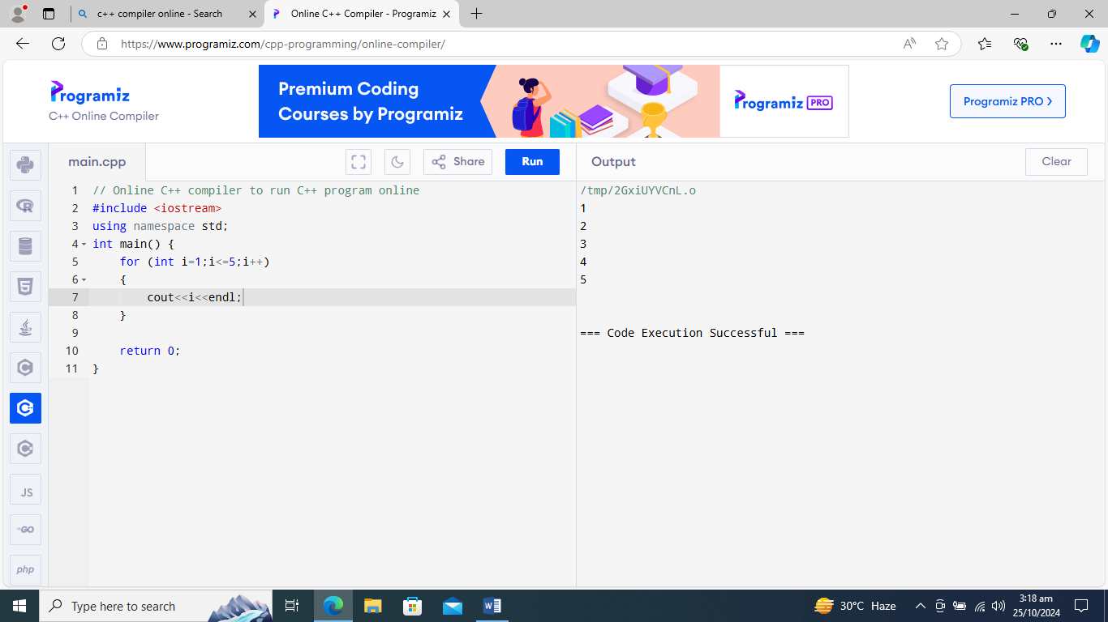

**Question 02 :** Write a program to find the sum of the first n numbers. The value of n should be provided by the user.

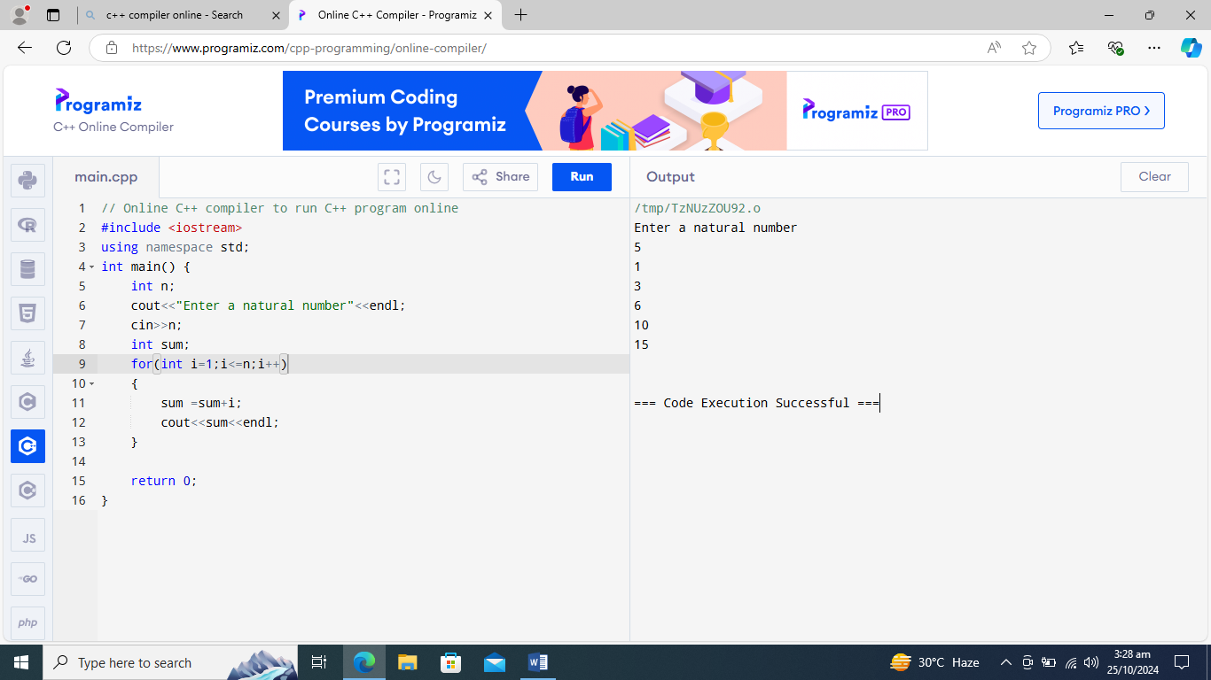

**Question 03**: Write a program that takes a number..user enter 5 .

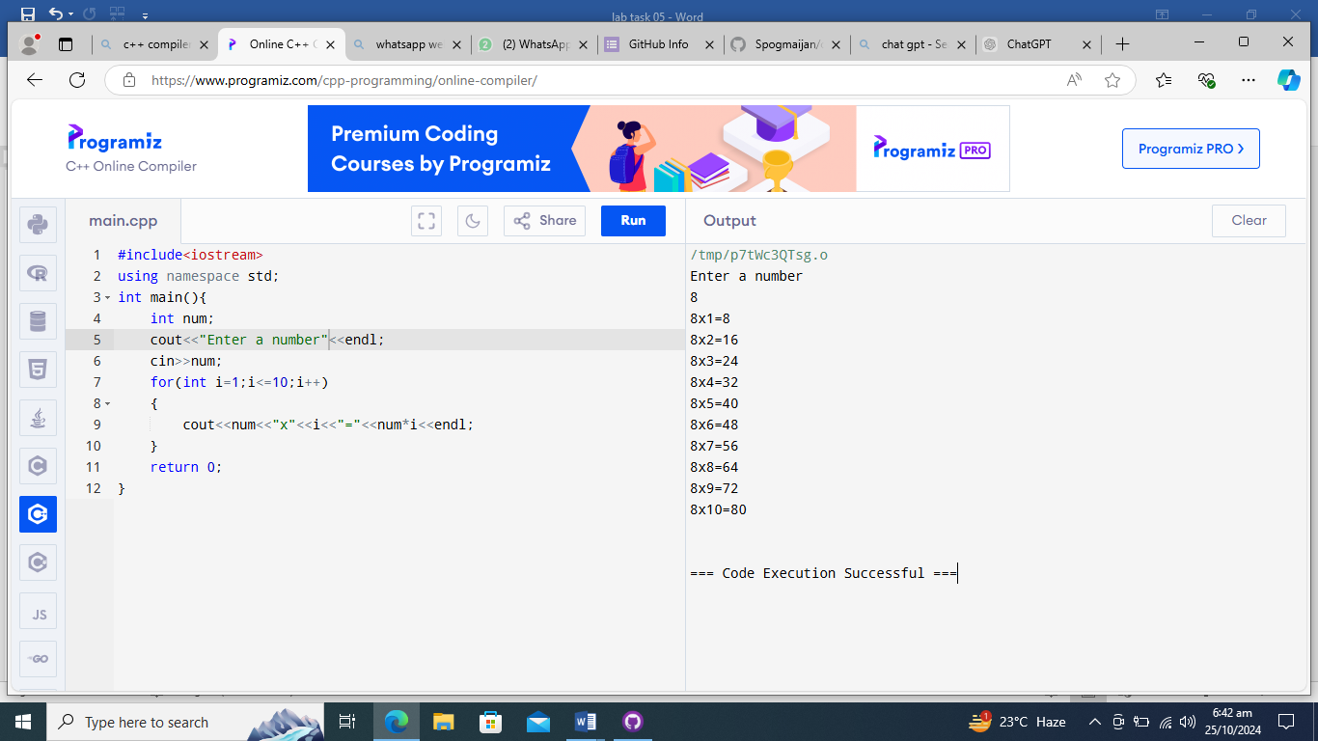

**Question 04** : Write a program that prints…using for loop.

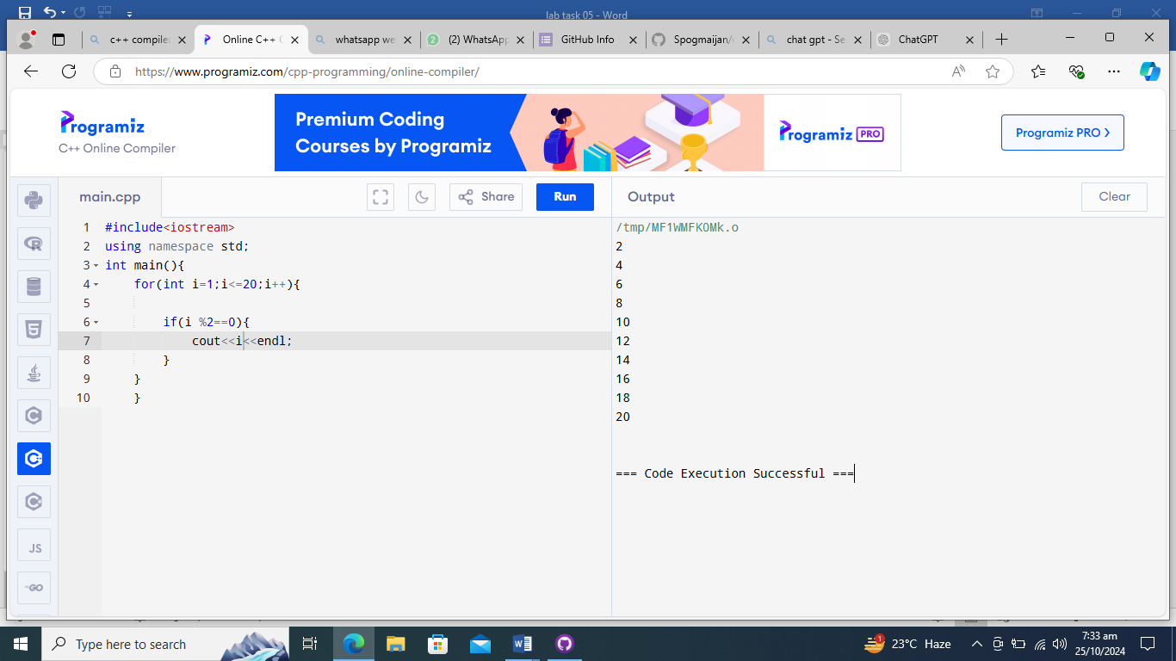

**Question 05** : Write a program that prints the number...10 to 1.

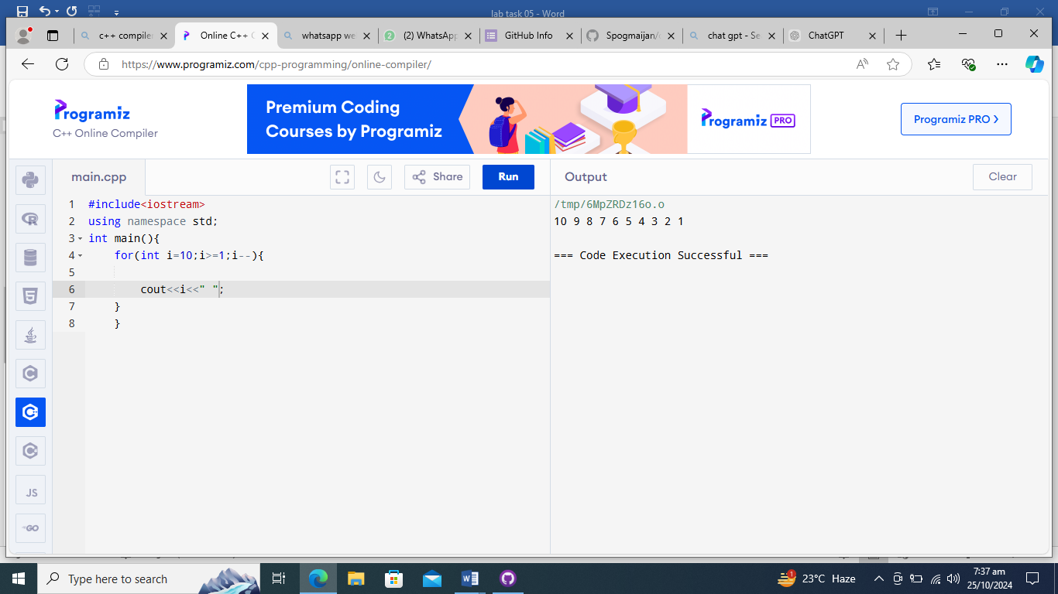

**Question 06**: Write a program in C++ to display the cube of the number up to an integer.

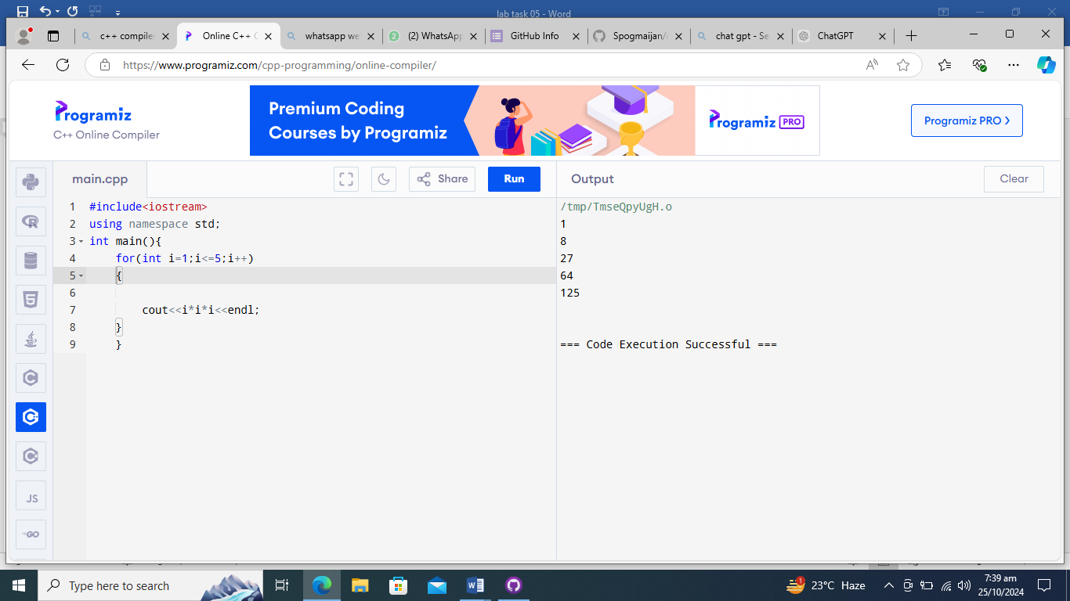**Question 07** : Display the corresponding grade for each student based on the entered marks. Display the appropriate grade.

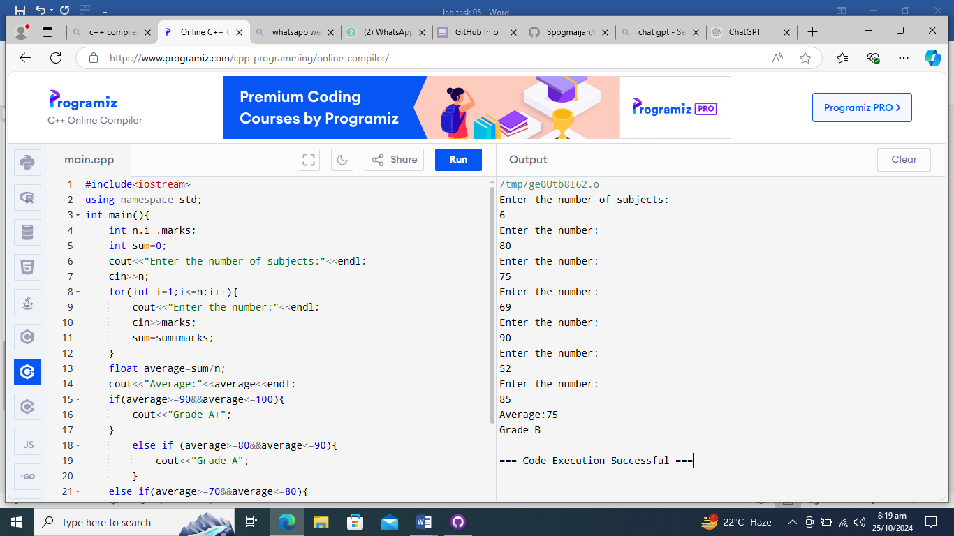

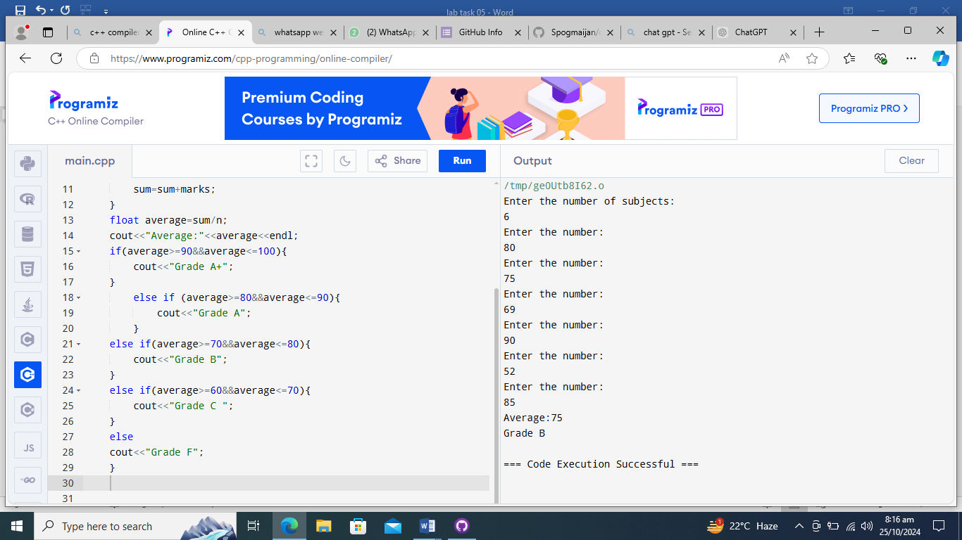

**--- THE END ---**